**Step 1: Setup your machine with Git Configuration**

To create a new repository, signup with GitLab and register your credentials Login to GitLab and create a “GitDemo” project

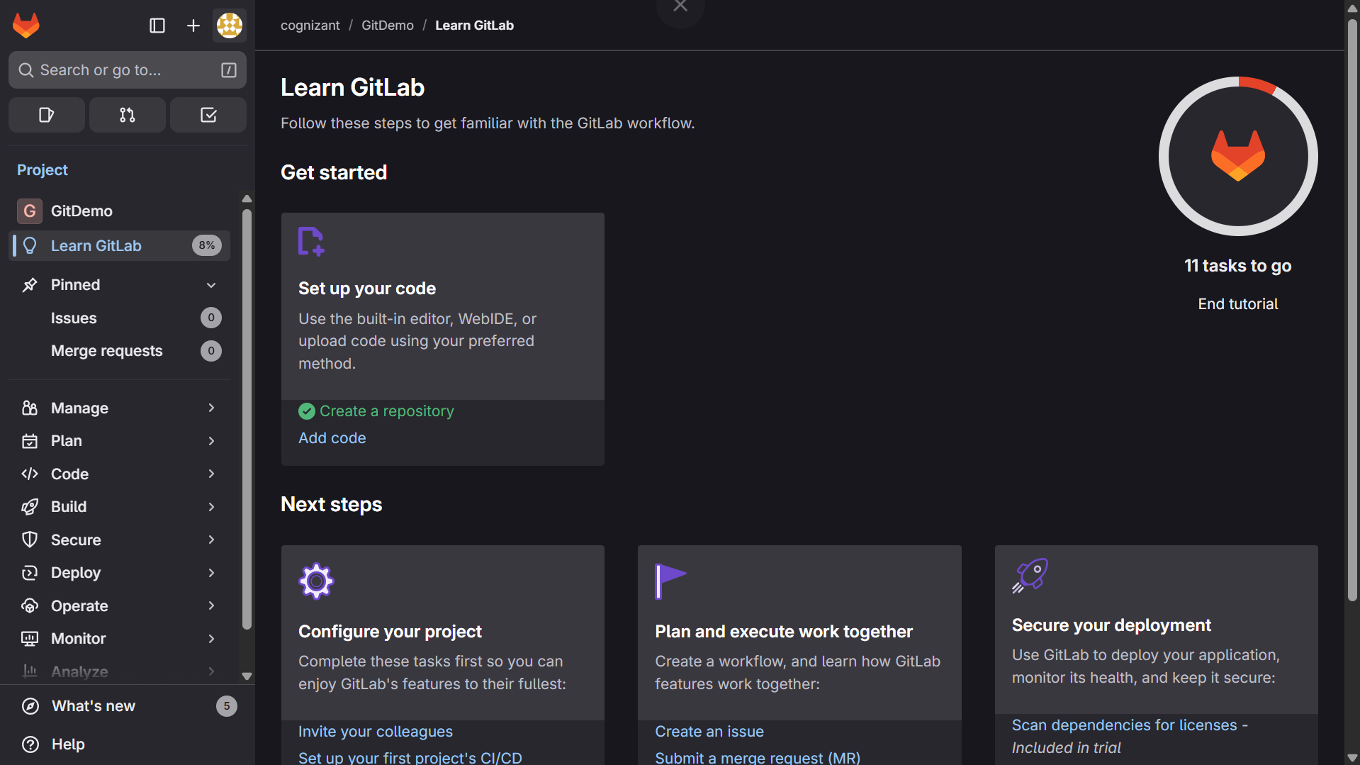

1. To check if Git client is installed properly: Open Git bash shell and execute

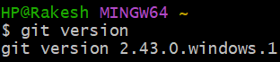

1. To configure user level configuration of user ID and email ID execute

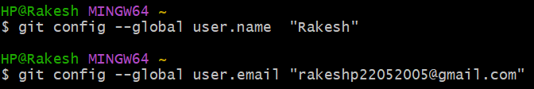

1. To check if the configuration is properly set, execute the following command.

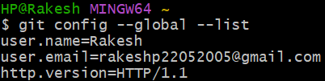

**Step 2: Integrate notepad++.exe to Git and make it a default editor**

1. To check, if notepad++.exe execute from Git bash

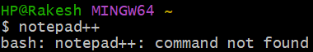

Adding notepad++.exe to path

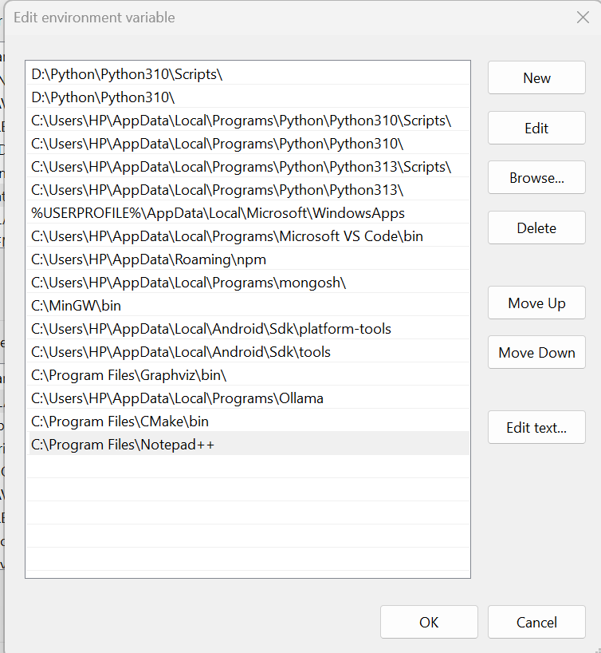

1. Exit Git bash shell, open bash shell and execute

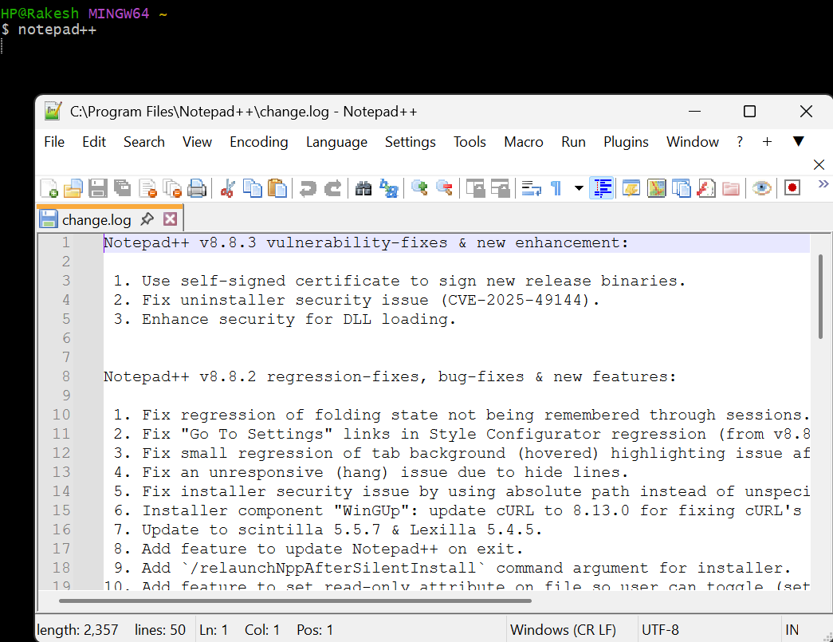

Now, notepad++ will open from Git bash shell

1. To configure the editor, execute the command



1. To verify if notepad++ is the default editor, execute the command

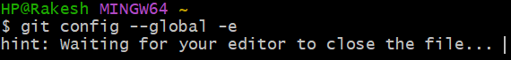

Here ‘-e’ option implies editor

It will show the entire global configuration as shown below,

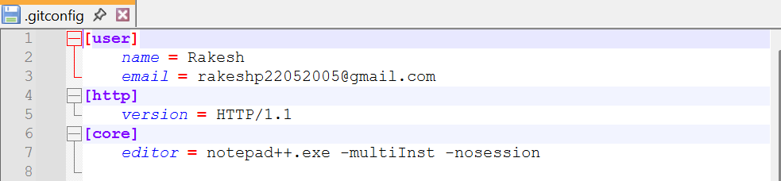

**Step 3: Add a file to source code repository**

1. Open Git bash shell and create a new project “**GitDemo**” by executing the command



1. Git bash initializes the “**GitDemo**” repository. To verify, execute the command

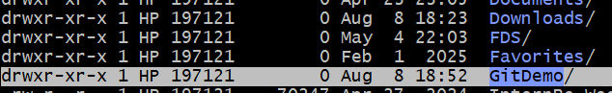

It will display all the hidden files in the Git “working directory”.

1. To create a file **“welcome.txt”** and add content to the file, execute the command



1. To verify if the file “welcome.txt” is created, execute





1. To verify the content, execute the command

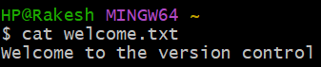

1. Check the status by executing

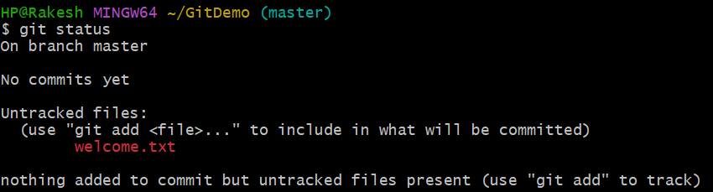

Now the file **“welcome.txt”** is available in Git “working directory”

1. To make the file to be tracked by Git repository, execute the command



1. To add multi line comments, we are opening default editor to comment. Execute the command

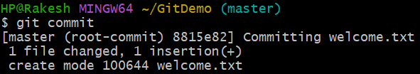

Notepad++ editor will open and to add multi-line comment with default editor

1. To check if local and “Working Directory” git repository are same, execute git status

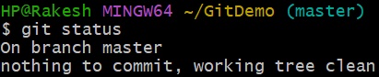

**welcome.txt** is added to the local repository.

1. Signup with GitLab and create a remote repository **“GitDemo”**

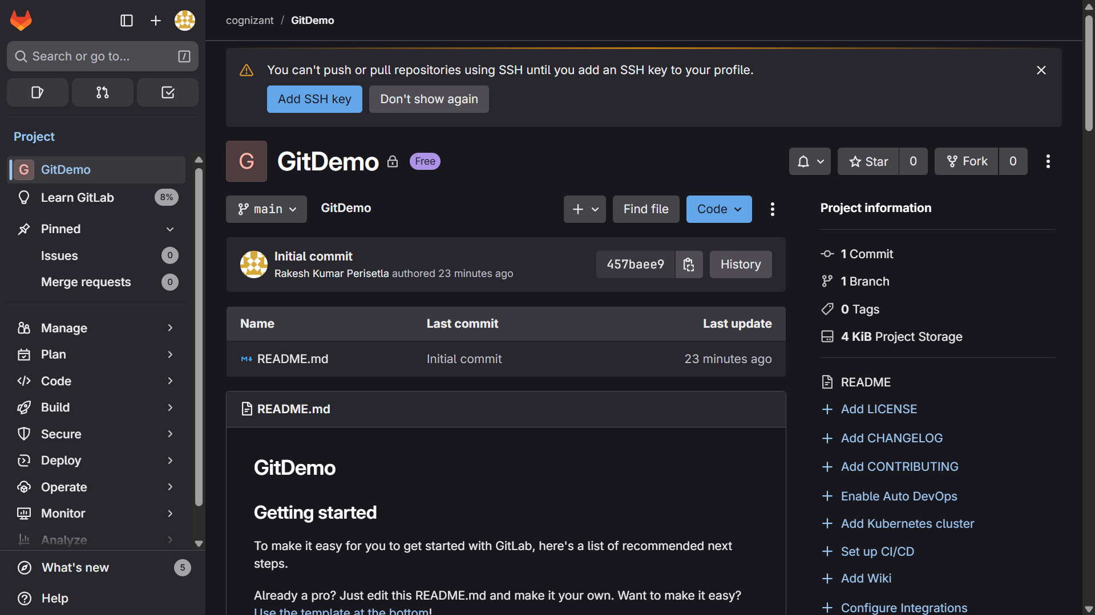

1. To pull the remote repository, execute

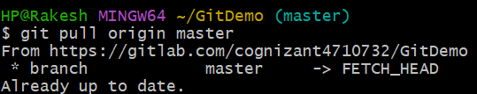

1. To push the local to remote repository, execute

